**Only the necessary parts of the codes are included. (No imread,imshow functions are showed)**

**Question 01**

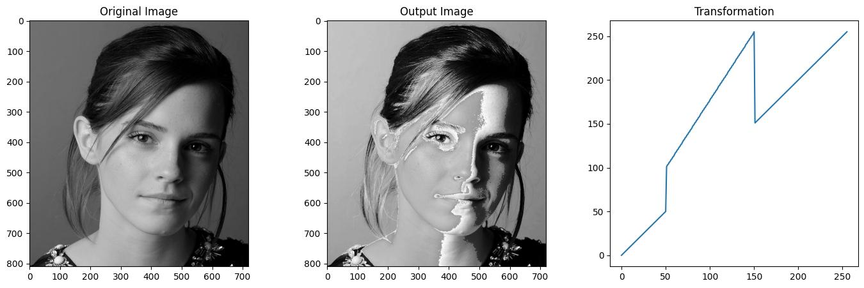import cv2 as cv  
import numpy as np  
import matplotlib.pyplot as plt  
  
coordinates = np.array([(0,0),(50,50),(50,100),(150,250),(150,150),(255,255)])  
trans = np.array([0])  
for i in range(int(len(coordinates)/2)):  
 line = np.linspace(coordinates[0+2*i ,1], coordinates[1+2*i ,1], coordinates[1+2*i , 0] - coordinates[0+2*i , 0] + 1)  
 trans = np.concatenate((trans , line)).astype(np.uint8)  
transformed = trans[image1]

***Question 02***

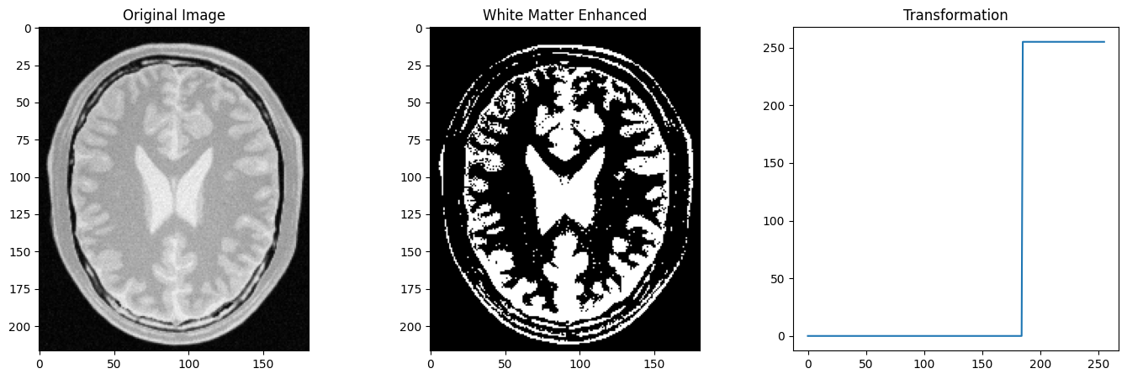***a)White Matter Enhanced***  
x = np.arange(0,256).astype(np.uint8)  
divert_point = 184  
coordinates = np.array([(1,0),(divert_point,0),(divert_point+1,255),(255,255)])  
trans = np.array([0])  
  
for i in range(int(len(coordinates)/2)):  
 line = np.linspace(coordinates[0+2*i ,1], coordinates[1+2*i ,1], coordinates[1+2*i , 0] - coordinates[0+2*i , 0] + 1)  
 trans = np.concatenate((trans , line)).astype(np.uint8)  
transformed = trans[image2]

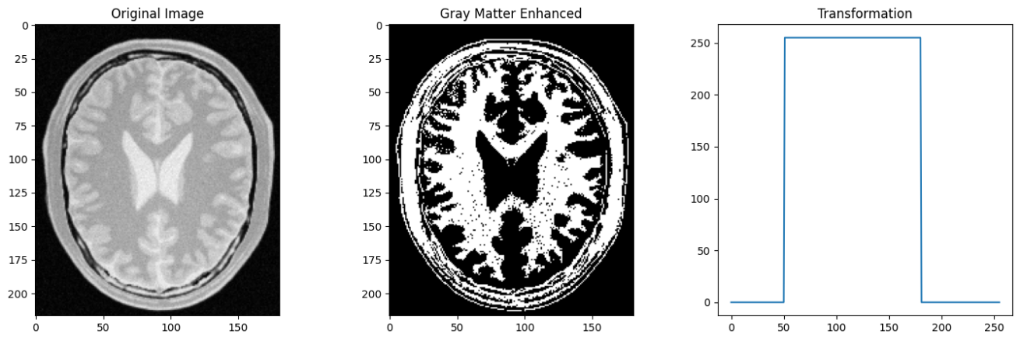***b)*** ***Gray Matter Enhanced***  
coordinates = np.array([(1,0),( 50,0),( 50+1,255),( 180,255),(180+1,0),(255,0)])  
trans = np.array([0])  
for i in range(int(len(coordinates)/2)):  
 line = np.linspace(coordinates[0+2*i ,1], coordinates[1+2*i ,1], coordinates[1+2*i ,0] - coordinates[0+2*i , 0] + 1)  
 trans = np.concatenate((trans, line)).astype(np.uint8)  
transformed = trans[image2]

***Question 03***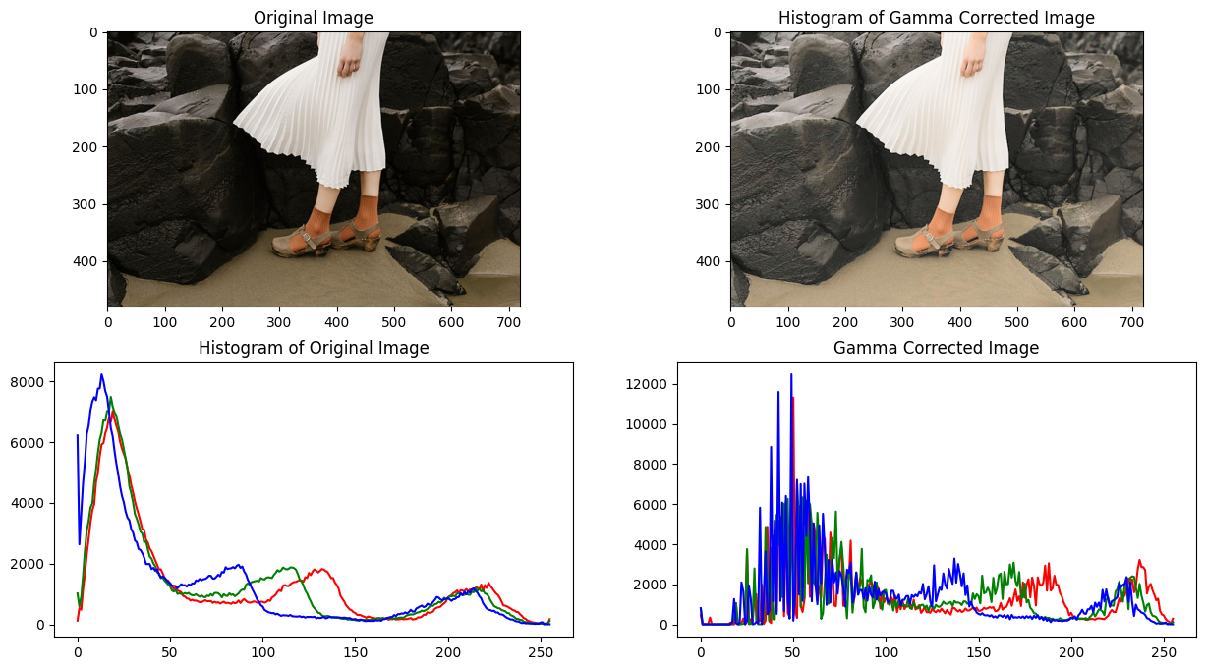  
image3_copy = image3.copy()  
image3_copy = cv.cvtColor(image3_copy,cv.COLOR_BGR2RGB)  
image3 = cv.cvtColor(image3, cv.COLOR_BGR2LAB)  
l_img , a_img , b_img = cv.split(image3)  
  
gamma = 0.5  
  
table = np.array([(i/255.0)**(gamma)*255.0 for i in np.arange(0,256)]).astype(np.uint8)  
img_gamma = cv.LUT(l_img, table)  
final_image = cv.merge((img_gamma, a_img, b_img))  
final_image = cv.cvtColor(final_image, cv.COLOR_LAB2RGB)

***Discussion***

* L channel : This plane represent the Lightness / Brightness of image.When adding gamma correction with gamma=0.5,it will increase the brightness of the L plane and the final output image.
* A plane : This plane represent the color from green to red. Negative value correspond to green while positive values correspond to red.
* B plane : This plane represent the color from blue to yellow. Negative value correspond to blue while positive values correspond to yellow.

***Question 04***  
hsv_image = cv.cvtColor(image4, cv.COLOR_BGR2HSV)  
hue, saturation, value = cv.split(hsv_image)  
a , alpha = 0.65, 70  
x = np.arange(0,256,1).astype(np.uint8)  
table = np.array([min(255, (x + (a * 128) * np.exp(-((x - 128) ** 2) / (2 * alpha ** 2)))) for x in np.arange(0, 256)]).astype('uint8')  
sat_update = cv.LUT(saturation, table)  
merge_img = cv.merge((hue, sat_update , value))  
merge_img = cv.cvtColor(merge_img, cv.COLOR_HSV2RGB)

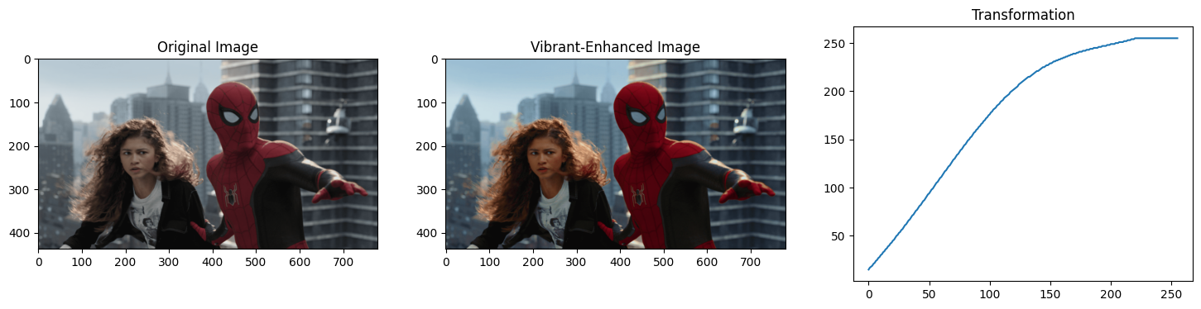**‘a’ value that output a visually pleasing image : 0.65**  
 ***Question 05***  
height, width = image5.shape[0], image5.shape[1]  
r_plane, g_plane, b_plane = cv.split(image5)  
def intensity_count(plane) :  
 count_list = np.zeros(256).astype(np.uint16)  
 for i in range(height) :  
 for j in range(width) :  
 count_list[plane[i][j]] += 1  
 return count_list  
def histogram_eq(plane, intensity_count) :  
 equalized_intensities = np.zeros(256).astype(np.uint16)  
 count = 0  
 for i in range(len(intensity_count)) :  
 count += intensity_count[i]   
 new_val = (255/(height*width)) * count  
 new_val = round(new_val)  
 equalized_intensities[i] = new_val  
  
 for h in range(height) :  
 for w in range(width) :  
 plane[h][w] = equalized_intensities[plane[h][w]]  
 return plane  
  
r_plane_count = intensity_count(r_plane)  
eq_r_plane = histogram_eq(r_plane, r_plane_count)  
g_plane_count = intensity_count(g_plane)  
eq_g_plane = histogram_eq(g_plane, g_plane_count)  
b_plane_count = intensity_count(b_plane)  
eq_b_plane = histogram_eq(b_plane, b_plane_count)  
new_image = cv.merge((eq_r_plane,eq_g_plane,eq_b_plane))  
  
  
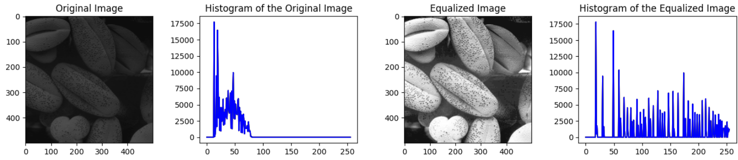***Question 06  
Part a,b,c***  
h_plane, s_plane, v_plane = cv.split(image6_hsv)  
th_val, binary_image = cv.threshold(s_plane, 11, 255, cv.THRESH_BINARY)  
result = cv.bitwise_and(image6, image6, mask = binary_image)

***Part d***

hist, bins = np.histogram(result.ravel(),256,[0,256])  
cdf = hist.cumsum()  
cdf_normalized = cdf * hist.max() / cdf.max()

***Part e***

result_r , result_g, result_b = cv.split(result)  
equ_r, equ_g, equ_b = cv.equalizeHist(result_r), cv.equalizeHist(result_g), cv.equalizeHist(result_b)

***Part f***

equalized_result = cv.merge((equ_r, equ_g, equ_b))

backgnd_mask = cv.bitwise_not(binary_image)

backgnd = cv.bitwise_and(image6, image6, mask = backgnd_mask)  
final = cv.add(equalized_result, backgnd)

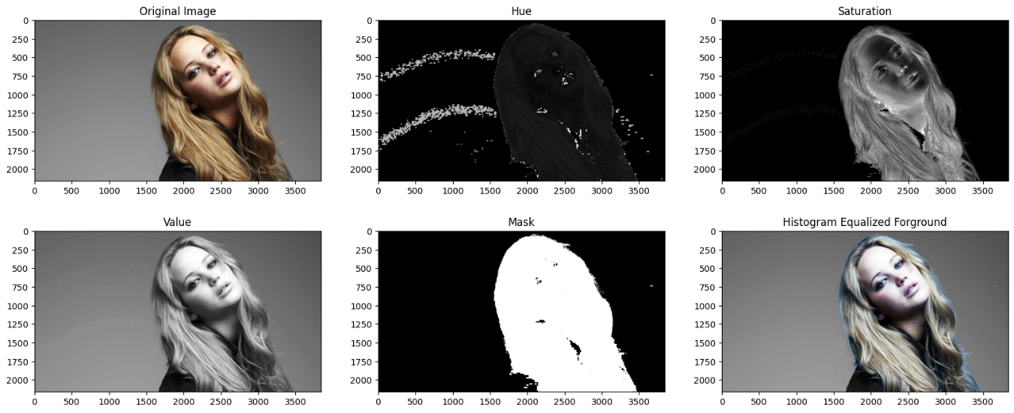  
***Question 07***

***Part a***

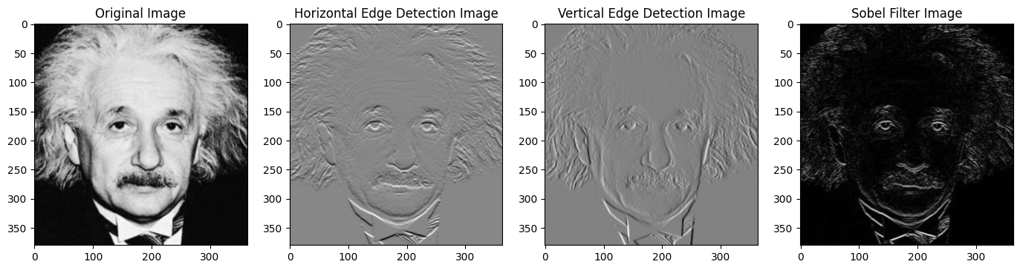image7 = cv.imread('einstein.png', cv.IMREAD_GRAYSCALE).astype(np.float32)  
vertical_sobel = np.array([[-1,-2,-1],[0,0,0],[1,2,1]], dtype = np.float32)  
horizontel_sobel = np.array([[-1,0,1],[-2,0,2],[-1,0,1]], dtype = np.float32)  
img_horizontal = cv.filter2D(image7, -1, vertical_sobel)  
img_vertical = cv.filter2D(image7, -1, horizontel_sobel)  
final_image = np.sqrt(img_horizontal**2, img_vertical**2)

***Part b***

def sobel_fiter(image, kernel):  
  
 h_im, w_im = image.shape[0] , image.shape[1]  
 h_ke, w_ke = kernel.shape[0] , kernel.shape[1]  
 h_ke_half, w_ke_half = h_ke // 2, w_ke // 2   
 result_h=np.zeros(image.shape,dtype=np.float32)  
 image = cv.normalize(image.astype('float'), None, 0.0, 1.0, cv.NORM_MINMAX)   
   
 for i in range(h_ke, h_im - h_ke):  
 for j in range(w_ke, w_im - w_ke):  
 # indentify the image window to get the 2D convolution with kernal, then convolution  
 image_window = image[i - h_ke_half : i + h_ke_half + 1, j - w_ke_half : j + w_ke_half + 1]   
 result_h[i, j] = np.sum(image_window * kernel)  
 result_h = (result_h - np.min(result_h)) / (np.max(result_h) - np.min(result_h)) * 255  
 return result_h  
  
img_h = sobel_fiter(image7, vertical_sobel)  
img_v = sobel_fiter(image7, horizontel_sobel)  
final_image = np.sqrt(img_horizontal**2, img_vertical**2)

***Part C***

kernal_vertical = np.array([-1,0,1],dtype=np.float32)  
kernal_horizontal = np.array([1,2,1],dtype=np.float32)  
img_vertical = cv.sepFilter2D(image7, -1, kernal_vertical, kernal_horizontal)  
img_horizontal = cv.sepFilter2D(image7, -1, kernal_horizontal, kernal_vertical)  
final_image = np.sqrt(img_horizontal**2, img_vertical**2)

***Question 08***

def zoom(image, scale, method) :  
 h_image , w_image , channels = image.shape  
 h_zoomed = h_image*scale  
 w_zoomed = w_image*scale  
 zoomed_image = np.zeros((h_zoomed, w_zoomed, channels), dtype = np.float32)  
 if method == 'nearest neighbour' :   
 for i in range(h_zoomed) :  
 for j in range(w_zoomed) :  
 zoomed_image[i,j] = image[i // scale, j // scale]  
  
 if method == 'bilinear interpolation' :  
 for i in range(h_zoomed) :  
 for j in range(w_zoomed) :  
 x_image , y_image = (i / scale) , (j / scale )  
 x1 , y1 = int(x_image) , int(y_image)  
 x2 , y2 = x1+1, y1+1  
 if x2 >= h_image : x2 = x1   
 if y2 >= w_image : y2 = y1  
 dx, dy = x_image - x1 , y_image - y1  
 w1,w2,w3,w4 =(1 - dx)*(1 – dy),dx*(1 - dy),(1 - dx)*dy, dx*dy  
 zoomed_image[i,j] = w1*image[x1,y1] + w2*image[x1,y2] + w3*image[x2,y1] + w4*image[x2,y2]  
 return zoomed_image.astype(np.uint8)  
  
zoomed_nn = zoom(image8, 4, 'nearest neighbour')  
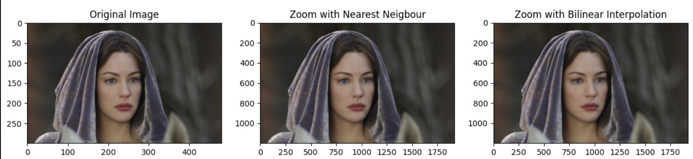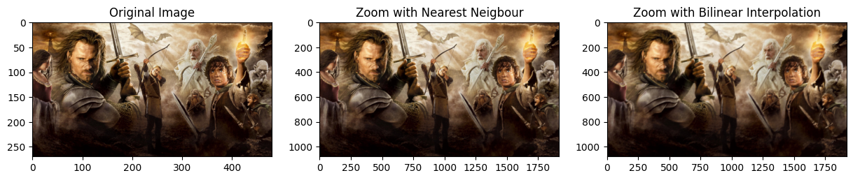zoomed_bi = zoom(image8, 4, 'bilinear interpolation')

***Discussion***Nearest neighbour method gives a sharp zoomed images while bilinear interpolation gives a smooth zoomed images. It happens because, interpolation method is taking the weighted sum of the four nearest pixel values. Therefore sharp edges will smooth when zooming images using bilinear interpolation.

***Question 08 algorithm testing (for image 01)***

zoomed_image = cv.imread('zooming/im01.png')  
resized = cv.resize(image8, (1920, 1080), interpolation=cv.INTER_LINEAR)  
squared_diff1 = np.sum(np.square(zoomed_image - zoomed_nn))  
squared_diff2 = np.sum(np.square(zoomed_image - zoomed_bi))  
squared_diff3 = np.sum(np.square(zoomed_image - resized))

Squared Difference of zoomed image by Nearest Neighbour : 522633462  
Squared Difference of zoomed image by the Bilinear interpolation : 543747100  
Squared Difference of zoomed image by the resize Function : 522553013

***Question 09***

h, w, _ = image9.shape  
mask = np.zeros((h, w), dtype = np.uint8)  
bgdModel = np.zeros((1,65),np.float64)  
fgdModel = np.zeros((1,65),np.float64)  
rectangle = (0,0,h,w)  
mask, bg_model, fg_model = cv.grabCut(image9, mask, rectangle, bgdModel, fgdModel, 5, cv.GC_INIT_WITH_RECT)  
  
new_mask = np.where((mask == 0) | (mask == 2), 0, 1).astype(np.uint8)  
foreground = image9 * new_mask[:, :, np.newaxis]  
background = image9 * (1 - new_mask[:, :, np.newaxis])  
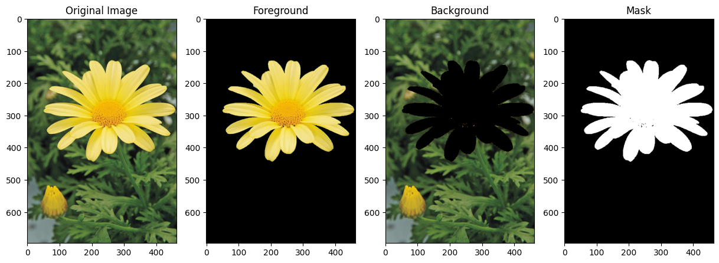

***Part B***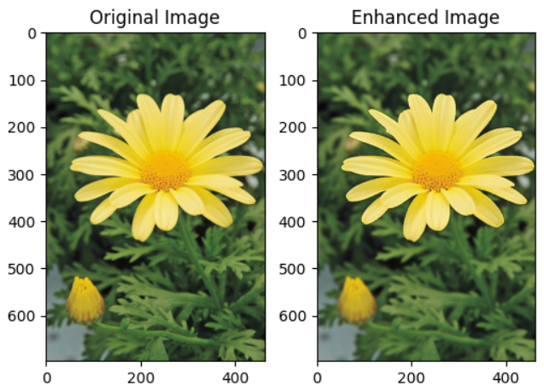blur_bg = cv.GaussianBlur(background, (11,11), 0,0)  
final_image = cv.add(foreground, blur_bg)

***Part C***

* Blurring the background decreases contrast and edge details. Deformations near the foreground edge can lead to darker appearances there.
* Using GrabCut for segmentation might misclassify edge pixels between foreground and background, leading to dark appearances near the foreground edge.

Name : R.M.S.Madhushan  
Index : 200363R  
GitHub Link : https://github.com/SadeepRathnayaka/EN3160_Assignment1